KEND -

Functionality
Realignment makes organizational changes in your product, customer, or sales structure - such as a reassignment of sales districts to regions or products to product groups - effective for all past data. You can perform realignments periodically.
This makes it possible for you to apply changes in customer or material master records, in the SD customer hierarchy, or in CO-PA derivation rules to the data that has already been posted to Profitability Analysis.
Following realignment, only the new assignment is known in the information system and in planning. The characteristic values valid at the time the original posting was made can only be analyzed in line item reports. Because the existing profitability segments are changed to adhere to the new assignment, all objects assigned to those profitability segments - such as sales orders or projects - and all existing SAP documents - such as billing documents or FI documents - reflect the new assignment as well.

Scenario
Create and run a realignment to update segments of product 64 to the new profit center that it was assigned to in the material master.
For instance we will take the scenario where in billing document 90000016 we have product 64 in plant 5201 where the profit center in the material master was corrected. Therefore we must now proceed with the derivation of division and profit center characteristics. After execution of a realignment run, check the line items in the report using option "Read according to new structure".

Requirements
The material 64 was changed in the plant 5201:
Division – previous ‘10’ Basic Chemicals, current ‘20’ Polyolefins
Profit Center – previous ‘1103’ Butadiene, current ‘1300’ Polyolefins
CO-PA documents were already posted in line with old values of characteristics.

Menu Path | SAP menu → Accounting → Controlling → Profitability Analysis → Master Data → KEND - Maintain Realignments
Transaction Code | KEND

1. Double click on KEND - Maintain Realignments.

CO-PA: Maintain Realignments

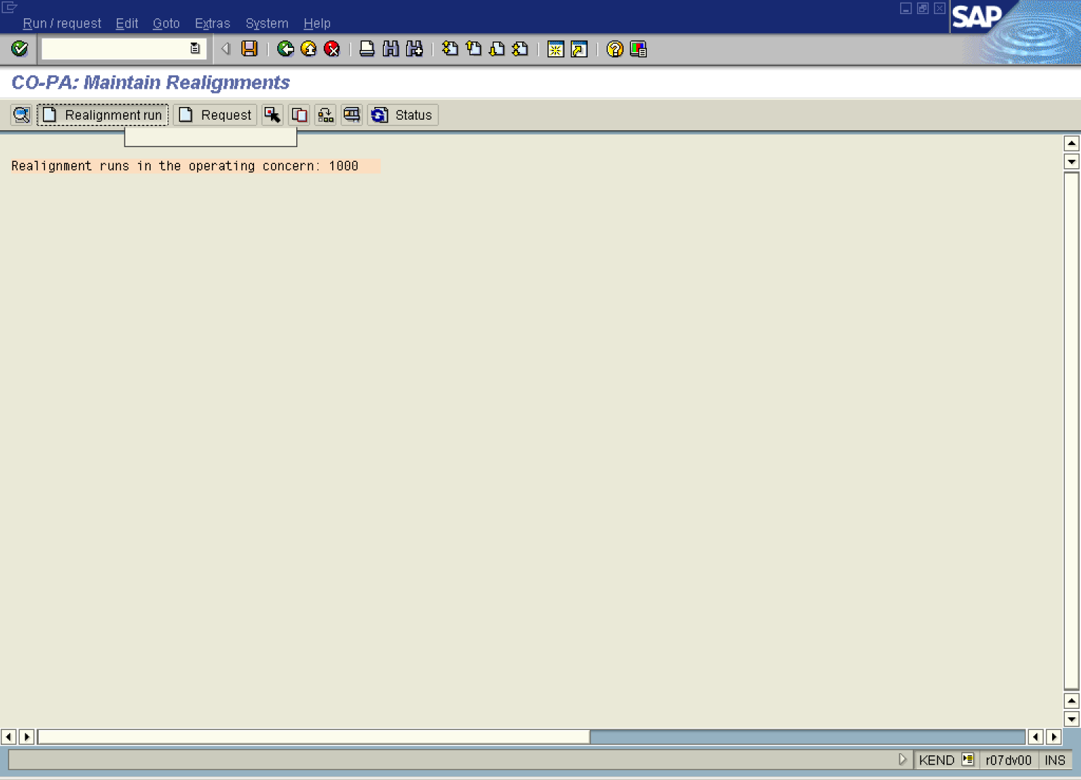

2. Click the Realignment run button.

Create Realignment Run

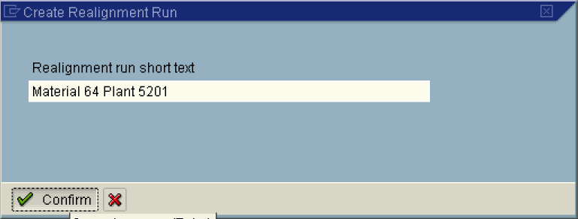

3. Update the following fields:

Field Name | Field Description | Values
Realignment short text | Description of the Realignment | Example: Material 64 Plant 5201

4. Click the Confirm button.

CO-PA: Maintain Realignments

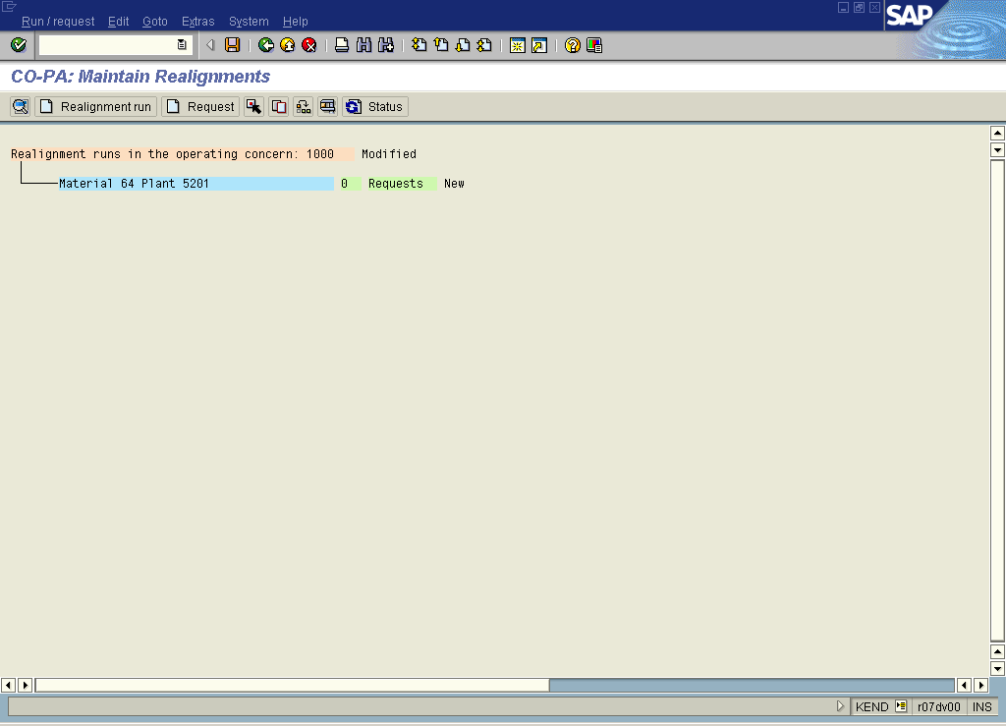

5. Click Material 64 Plant 5201 0 Requests New to mark.

6. Click Request .

CO-PA: Maintain Realignments

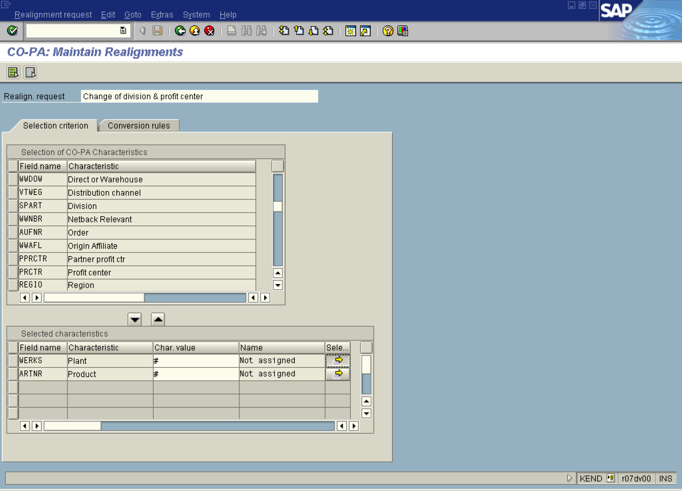

7. Update the following fields:

Field Name | Field Description | Values
Realign. Request | Description of the Realign. Request. | Example: Change of division & profit center

8. Click Plant Button .

9. Click WERKS .

Multiple Selection for WERKS

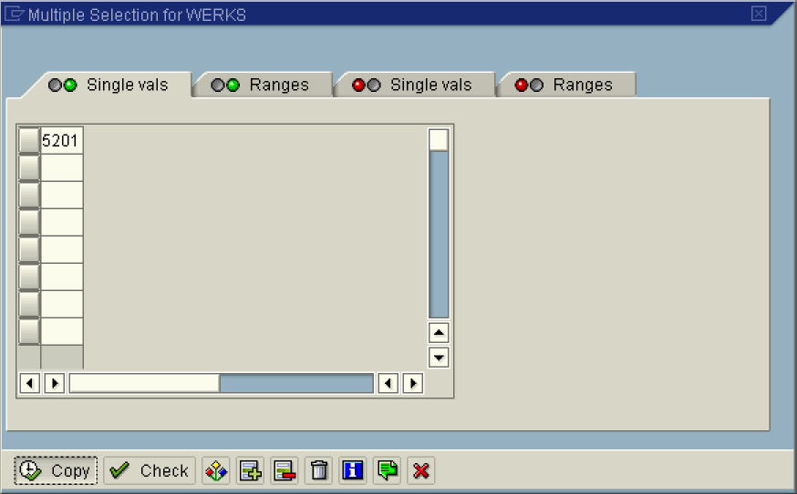

10. Update the following fields:

Field Name | Field Description | Values
Plant | Relevant plant number | Example: 5201

11. Click Copy .

CO-PA: Maintain Realignments

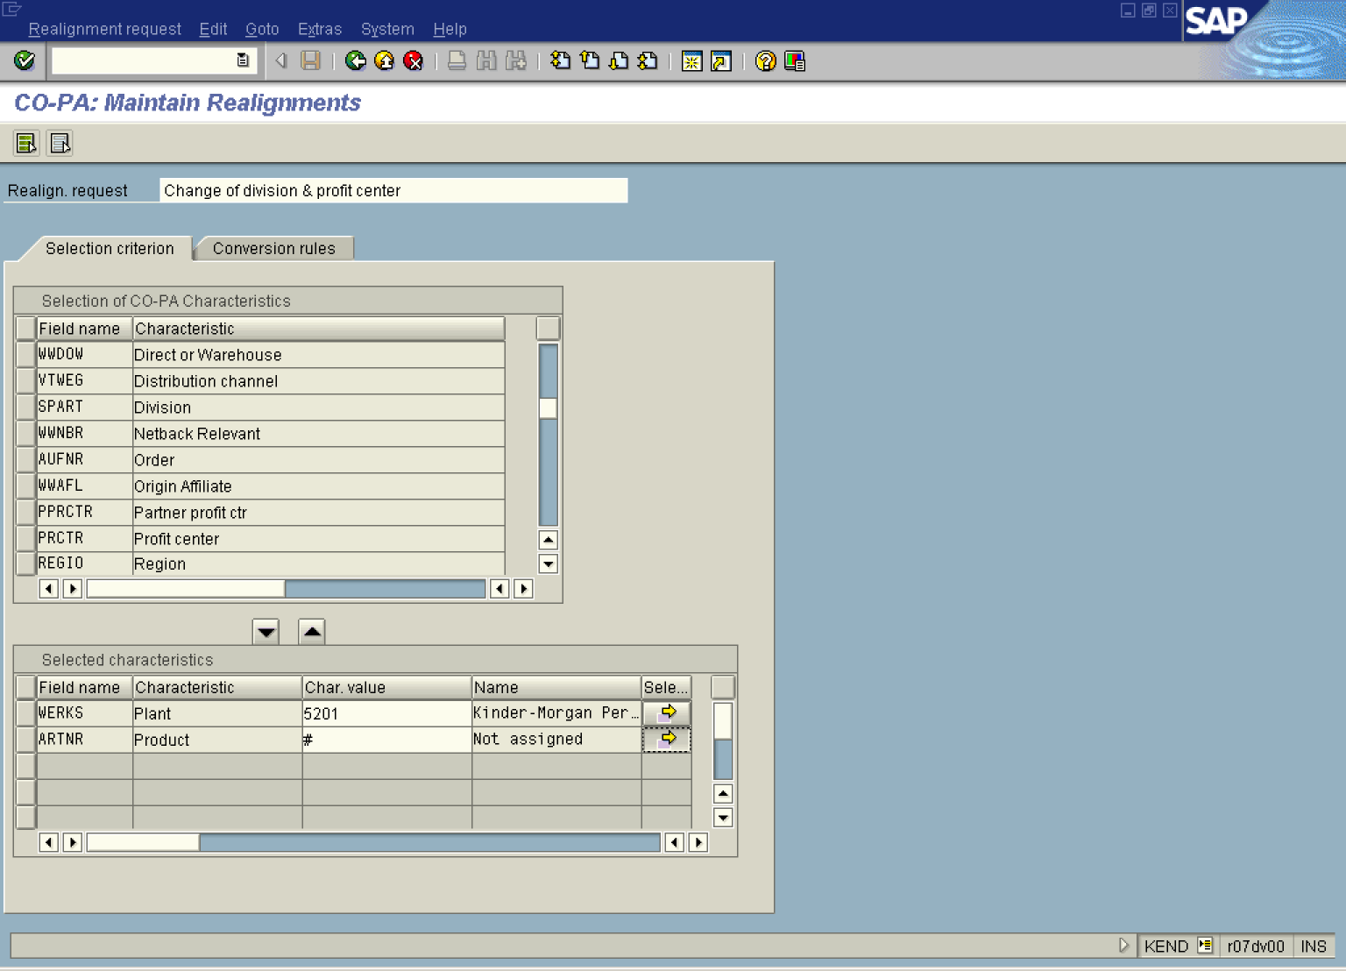

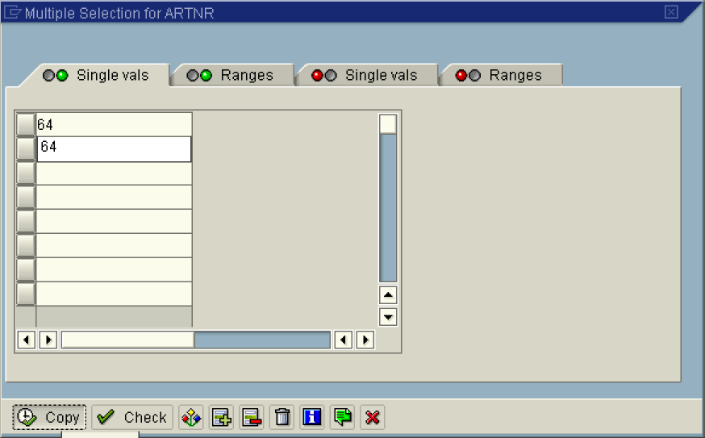

12. Update the following fields:

Field Name | Field Description | Values
Product | Material number | Example: 64

13. Click Copy .

CO-PA: Maintain Realignments

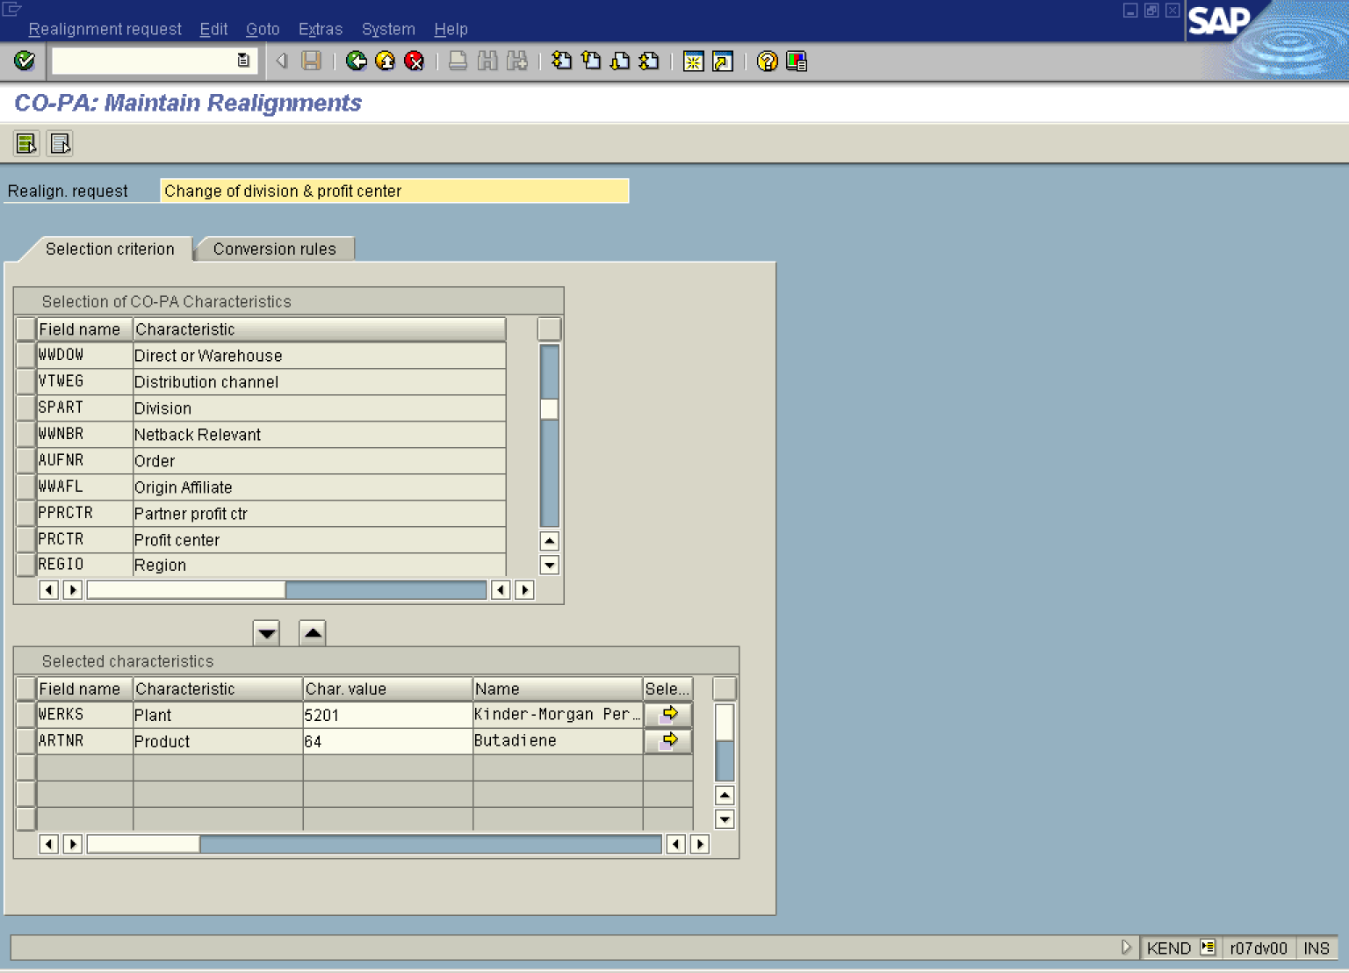

14. Click <tab button> Conversion rules .

CO-PA: Maintain Realignments

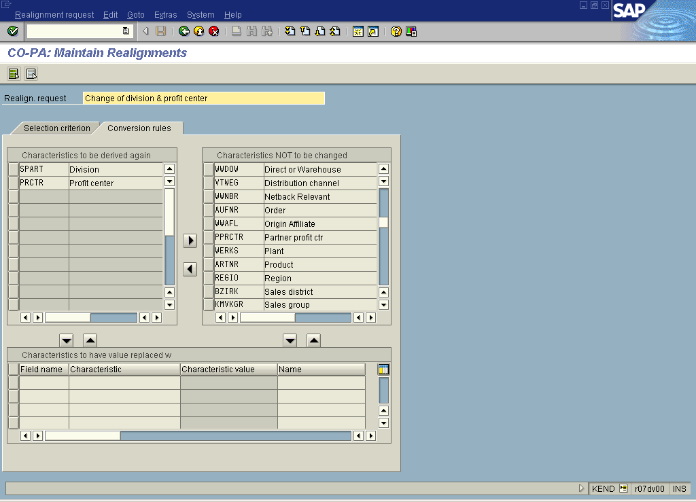

15. Click the Back button.

16. Click the Save button.

17. Click Material 64 Plant 5201 1 Requests New . To mark

18. Click Test Button .

Test Realignment Run

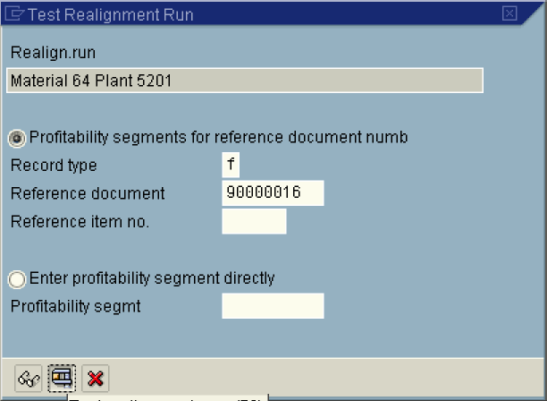

19. Update the following fields:

Field Name | Field Description | Values
Reference document | Reference document number | Example: 90000016

20. Click Button .

Test Result for Realignment Run 7

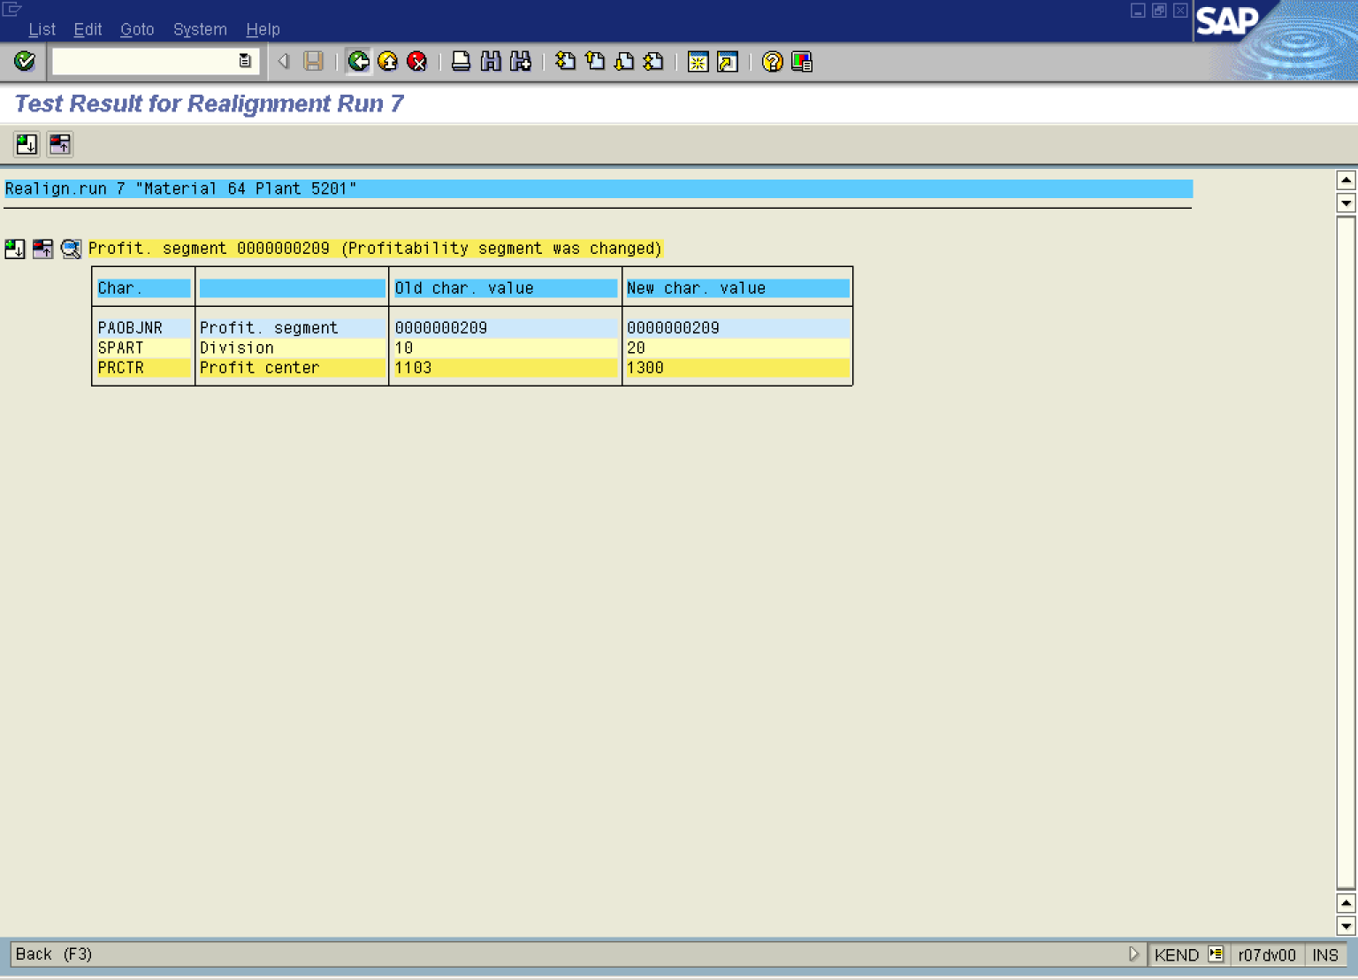

21. Click the Back button.

Test Realignment Run

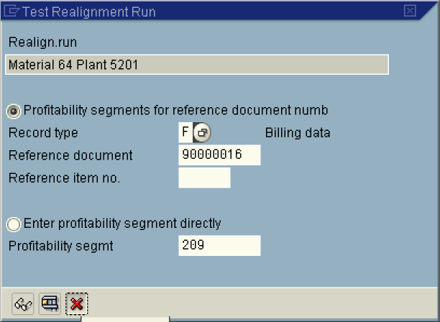

22. Click the Cancel button.

CO-PA: Maintain Realignments

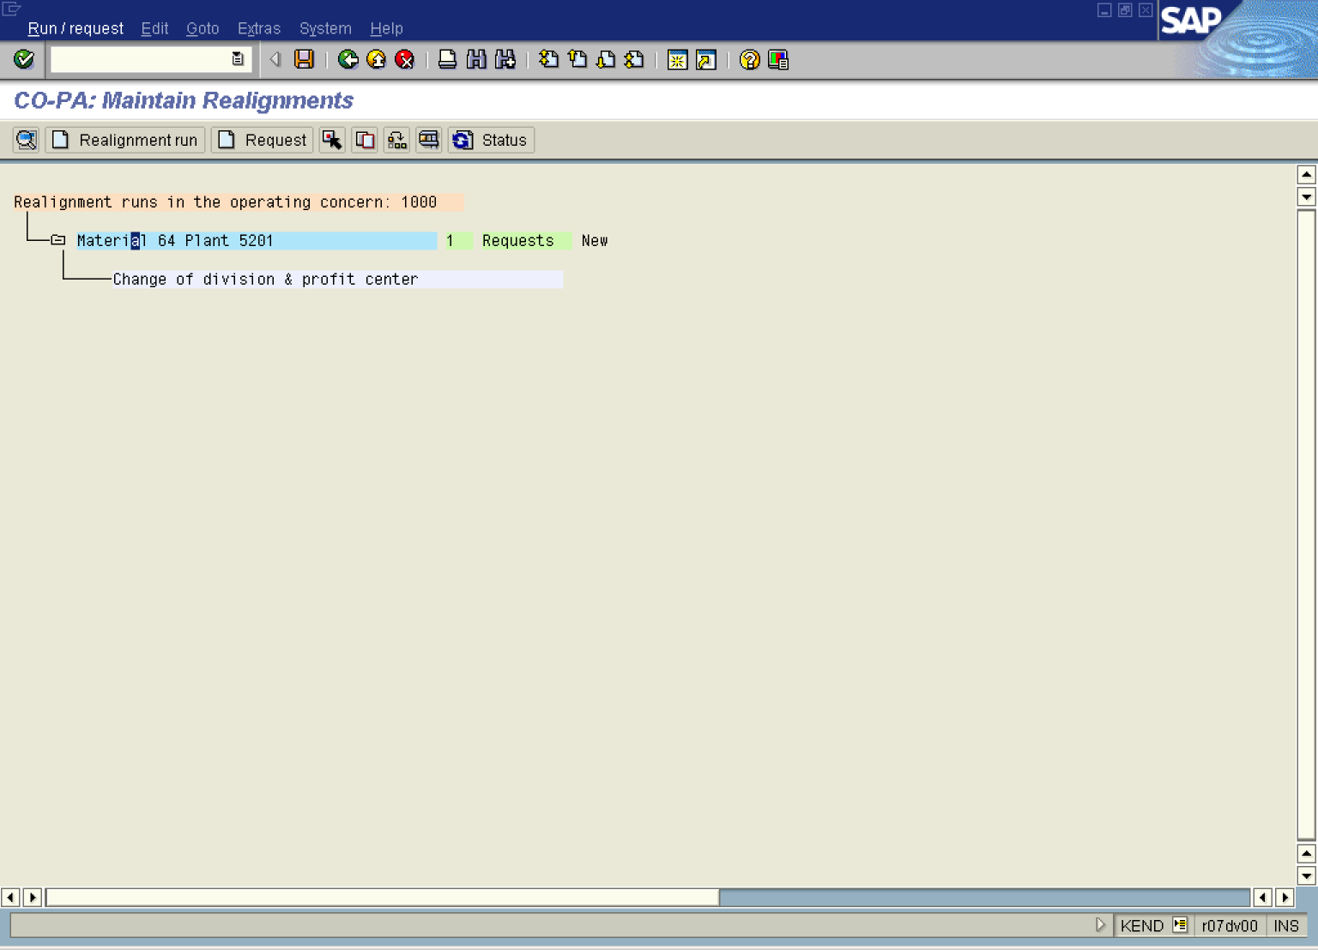

23. Select Run / requestExecuteWith starting ti me.

Enter Name for Background Job

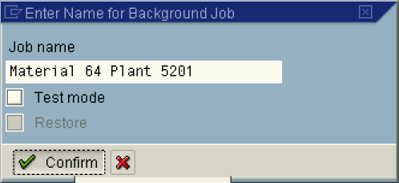

24. Click Test mode .

25. Click Confirm Button .

Start Time

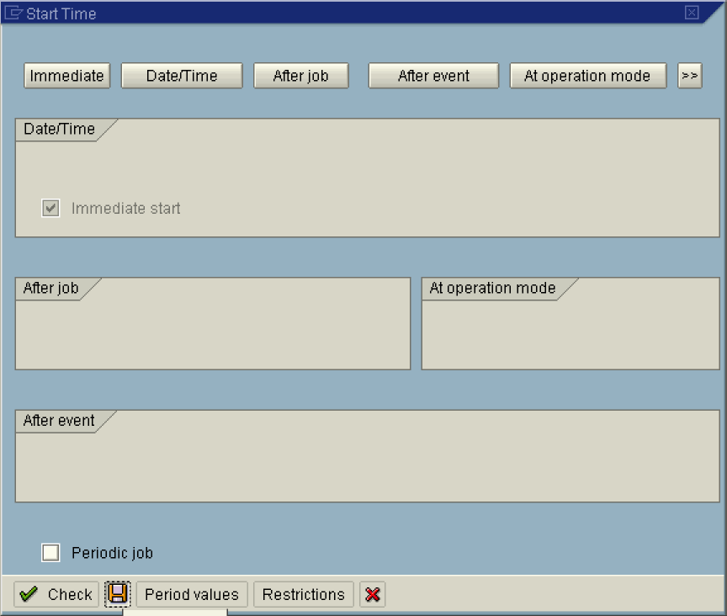

26. Click Immediate Button .

27. Click the Save button.

CO-PA: Maintain Realignments

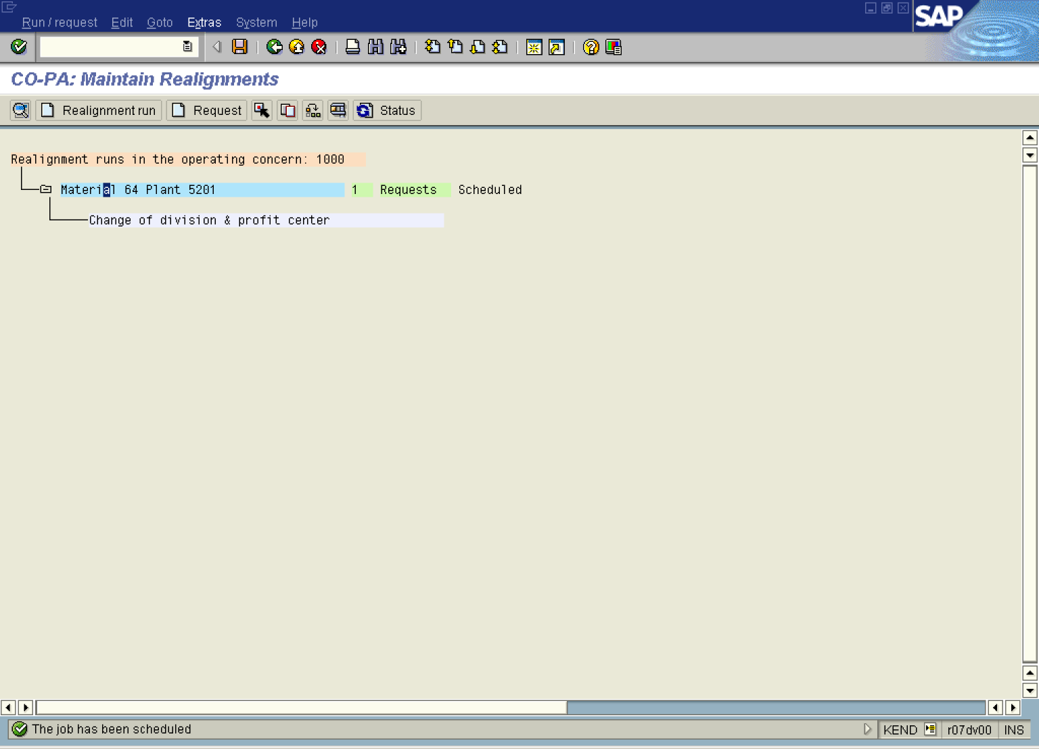

28. Select ExtrasJob overview.

29. Click Execute .

Job Overview

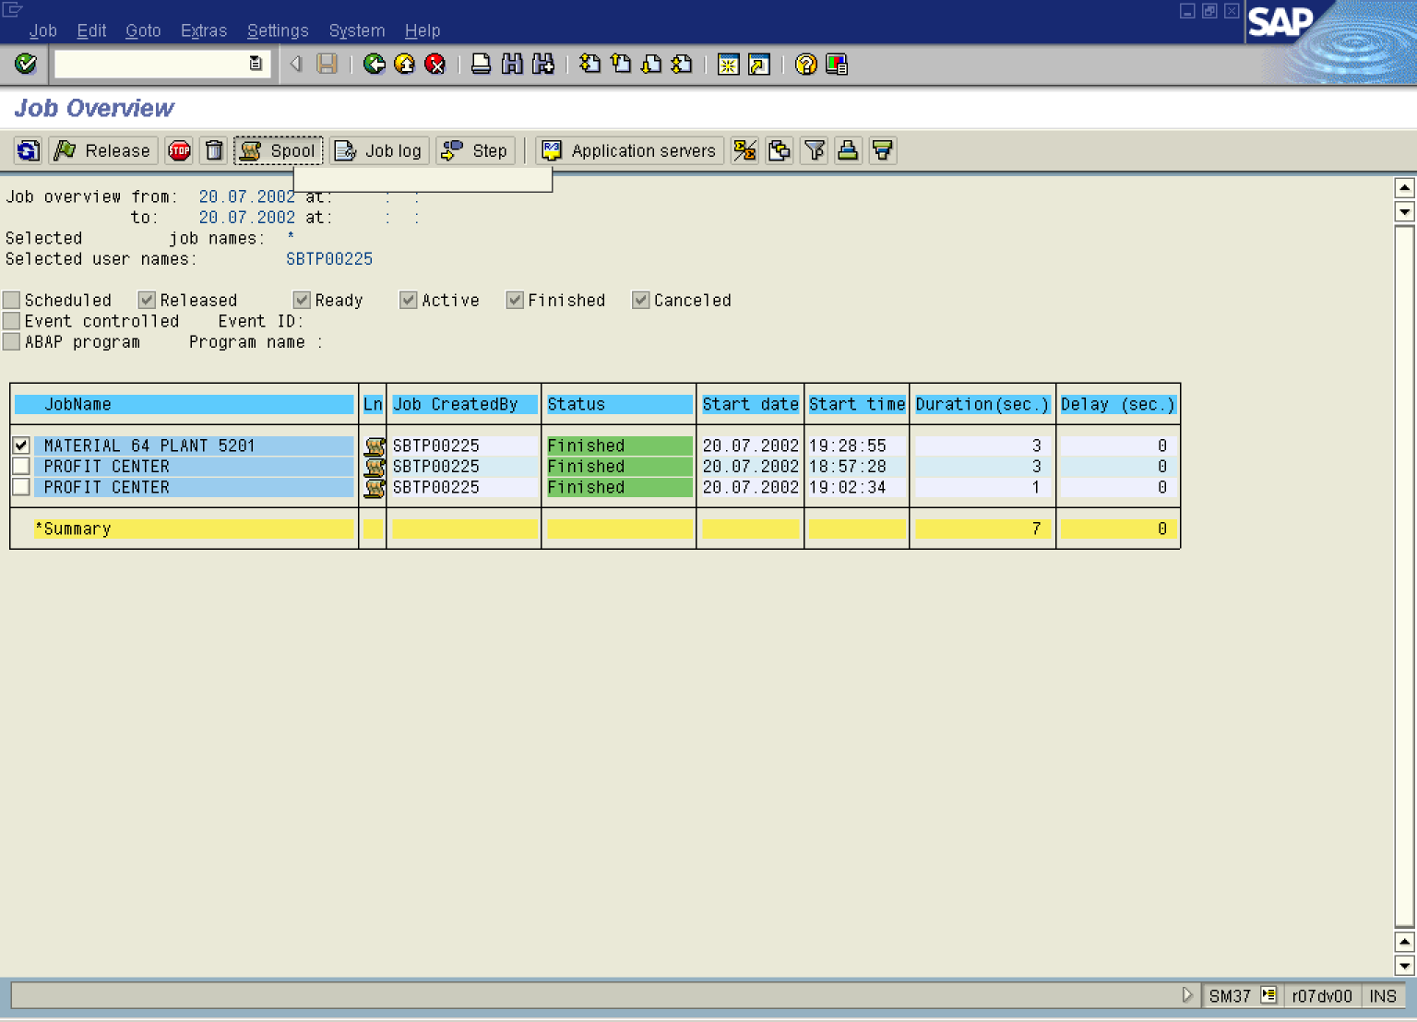

30. Click MATERIAL 64 PLANT 5201 Button . to mark.

31. Click Spool Button .

Output Controller: List of Spool Requests

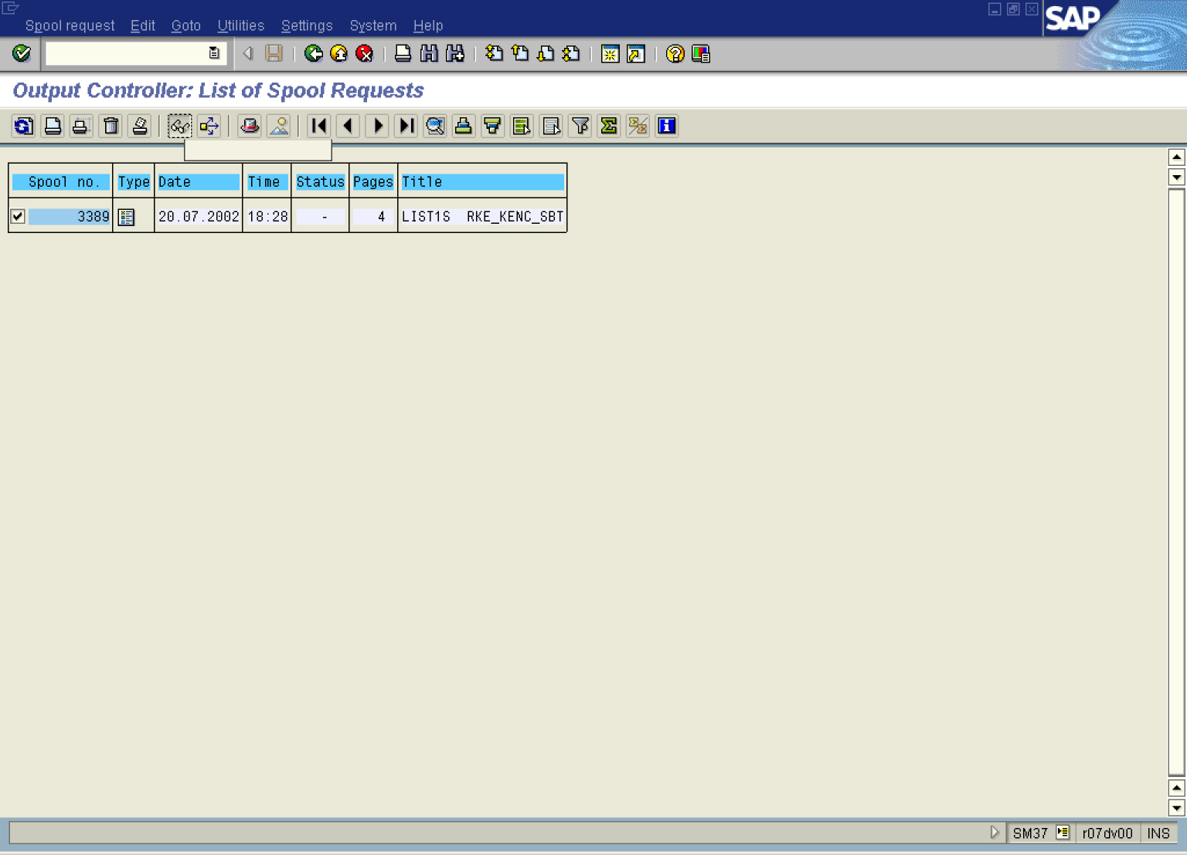

32. Click 3389 Button 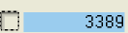 to mark.

33. Click Button .

Graphical display of spool request 3389 in system DS1

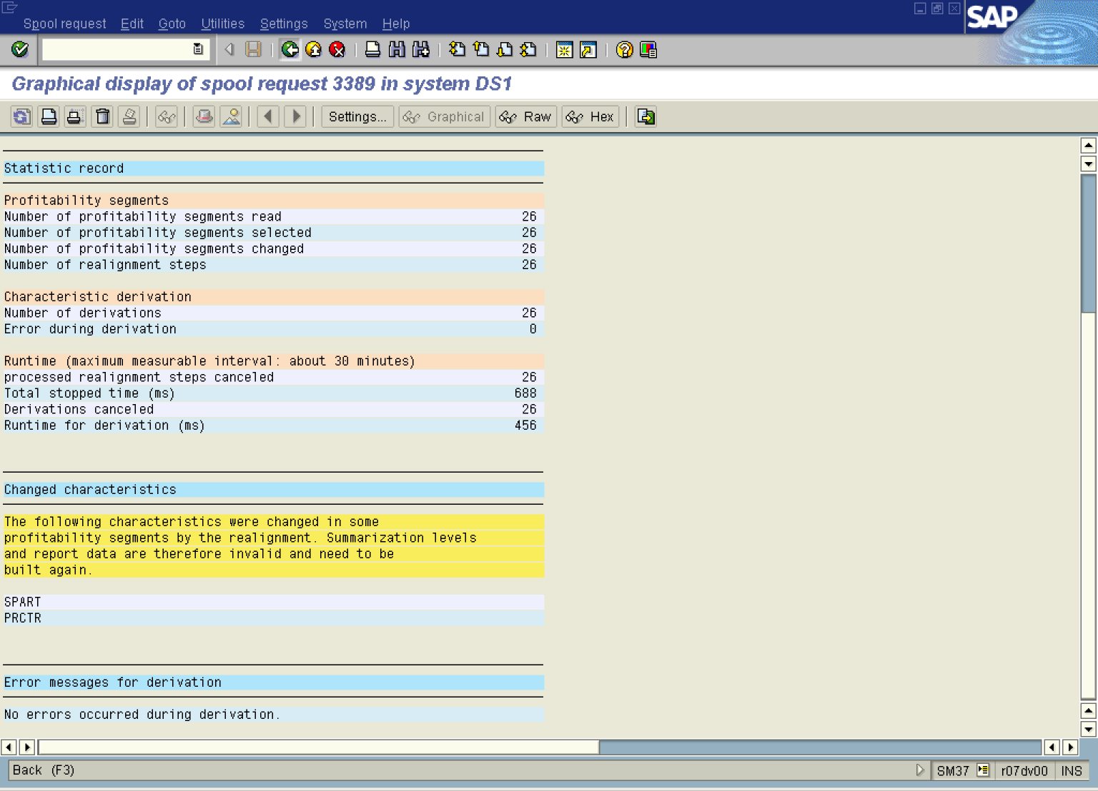

34. Click the Back button.

Output Controller: List of Spool Requests

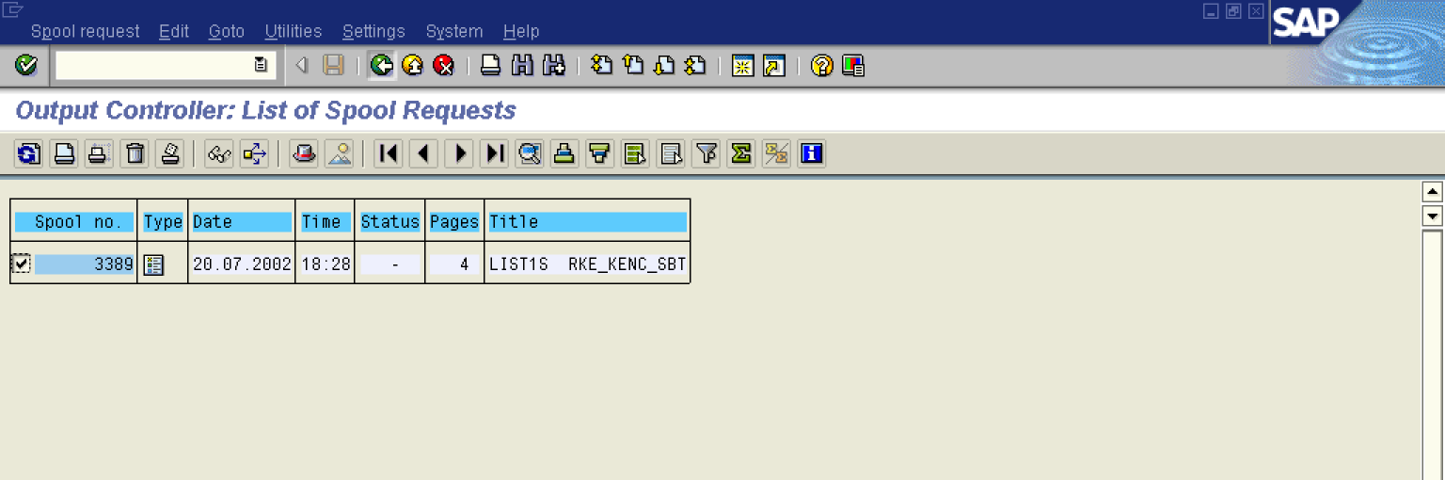

35. Click the Back button.

Job Overview

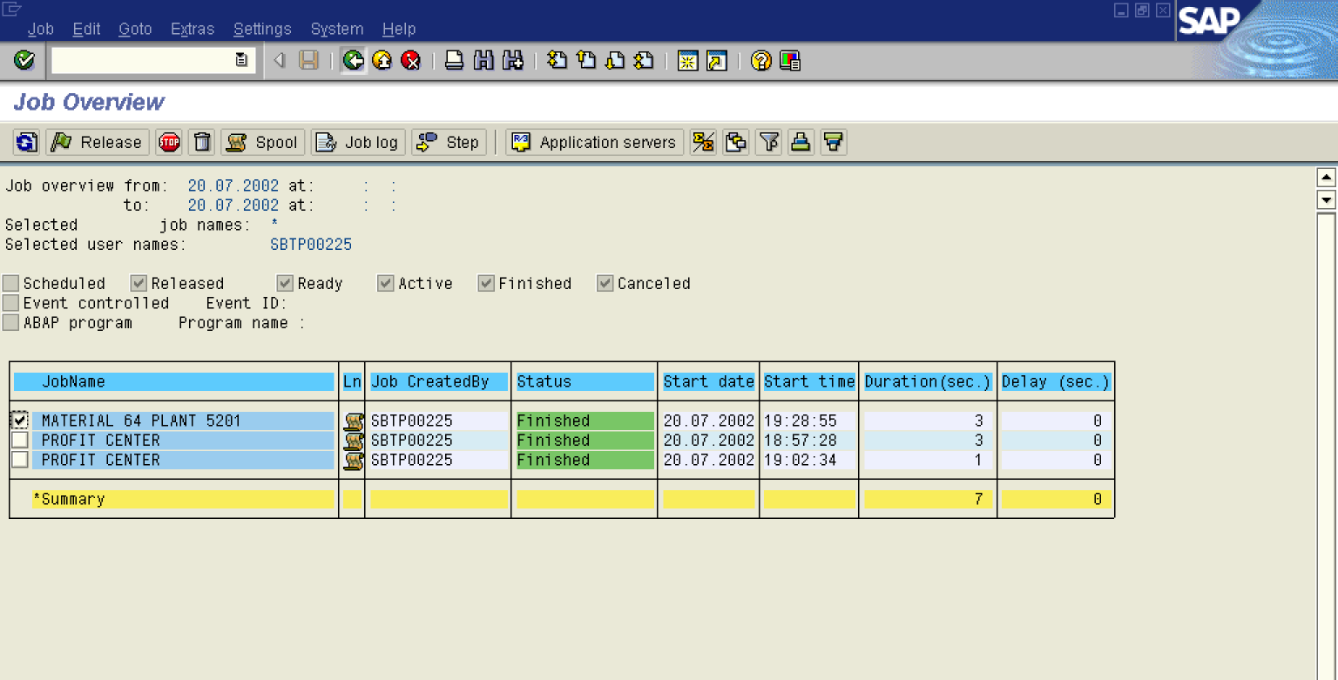

36. Click the Back button.

37. Click Back .

CO-PA: Maintain Realignments

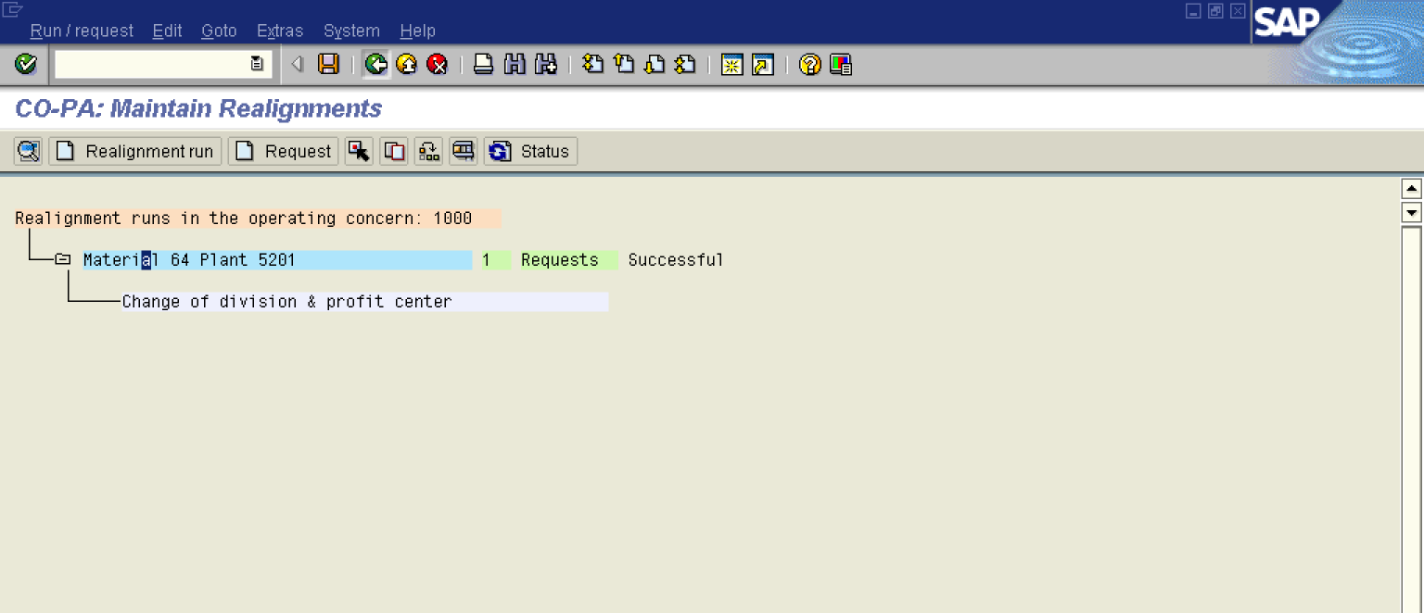

38. Click Status Button .

39. Click the Back button.

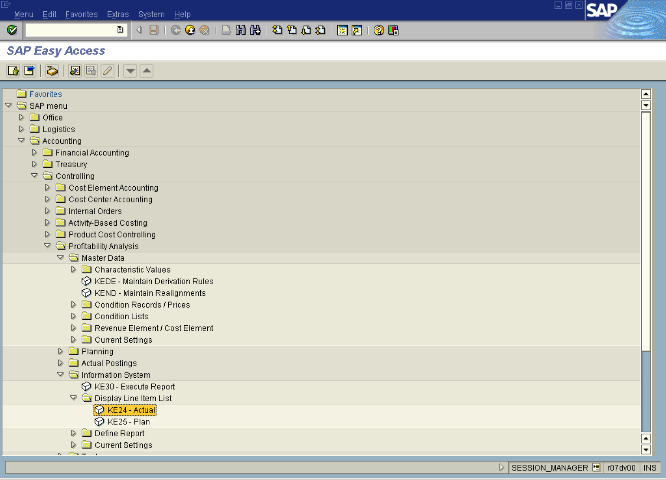

40. Select tree view node KE24 - Actual.

Display Actual Line Items: Initial Screen

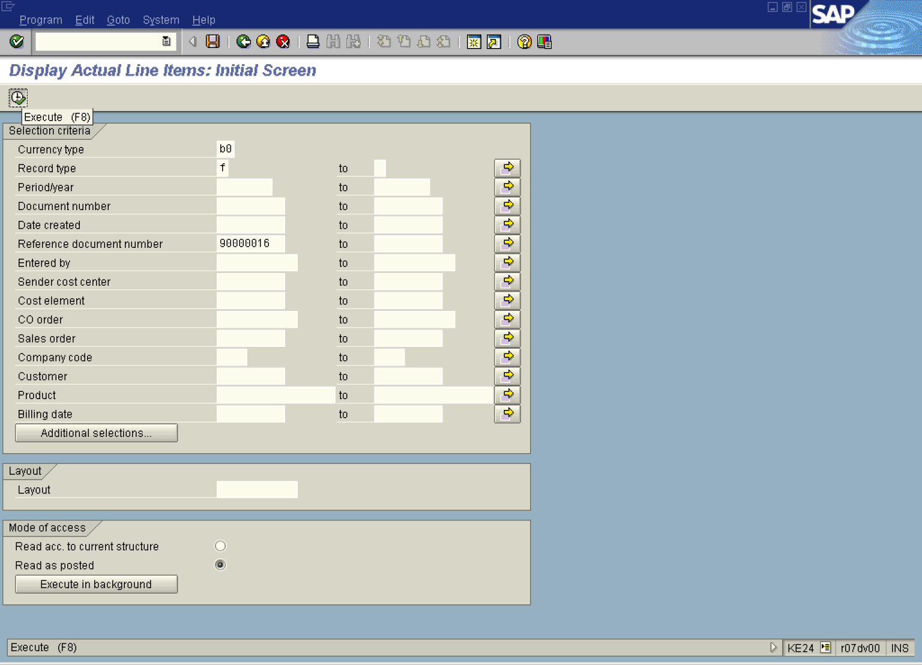

41. Update the following fields:

Field Name | Field Description | Values
Currency type | Operating Concern Currency | Example: B0
Record type | Billing document | Example: F
Reference document number | Relevant reference document number. | Example: 90000016

42. Click the Execute button.

Display Actual Line Items: List

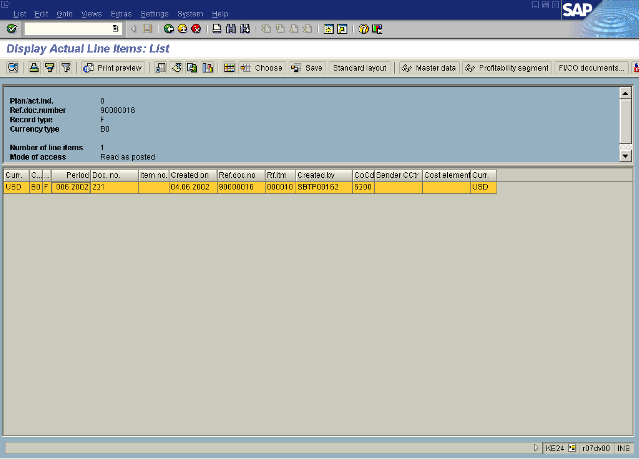

43. Select in list box to mark and double click on

44. Click the Back button.

Note: Division is still 10 and profit center is 1103. We made retroactive organizational changes to our product using the function "Realignments", and now we can display the line items according to the new structure by choosing "Read according to new structure".

Display Actual Line Items: List

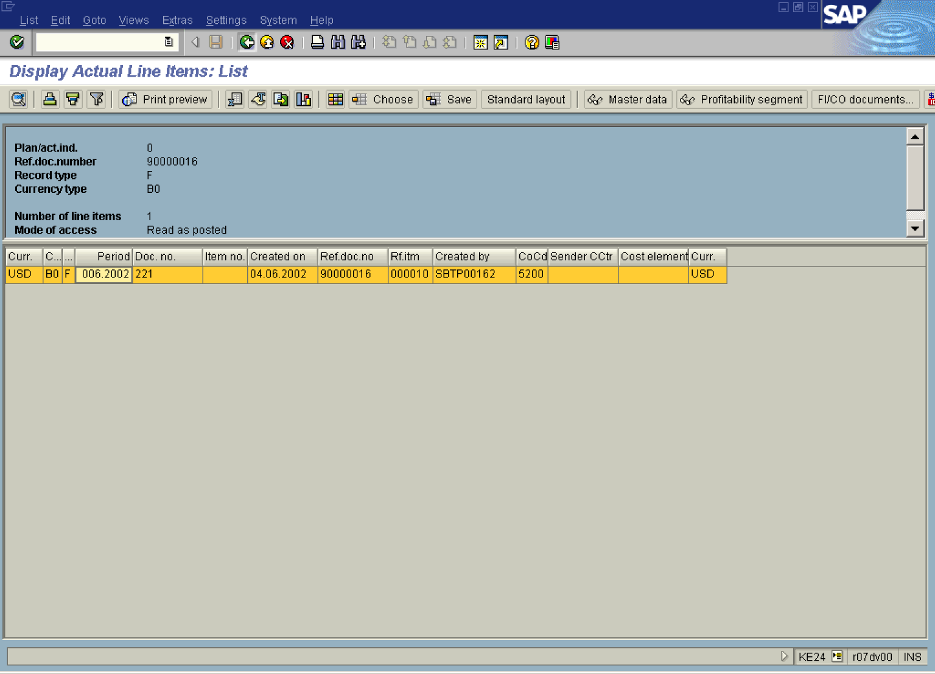

45. Click the Back button.

Display Actual Line Items: Initial Screen

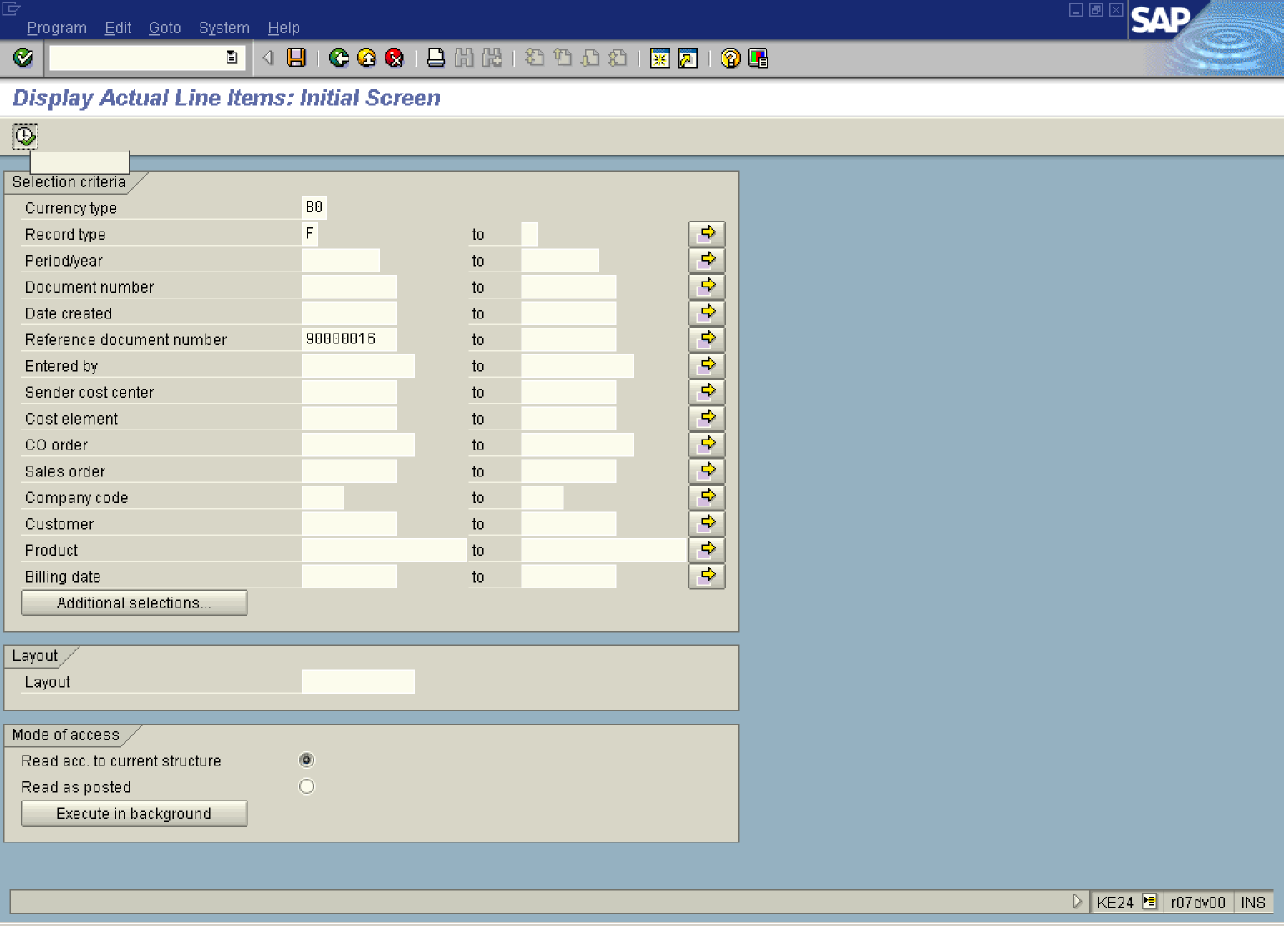

46. Click Read acc. to current structure .

47. Click the Execute button.

Line Items: Selection Criteria

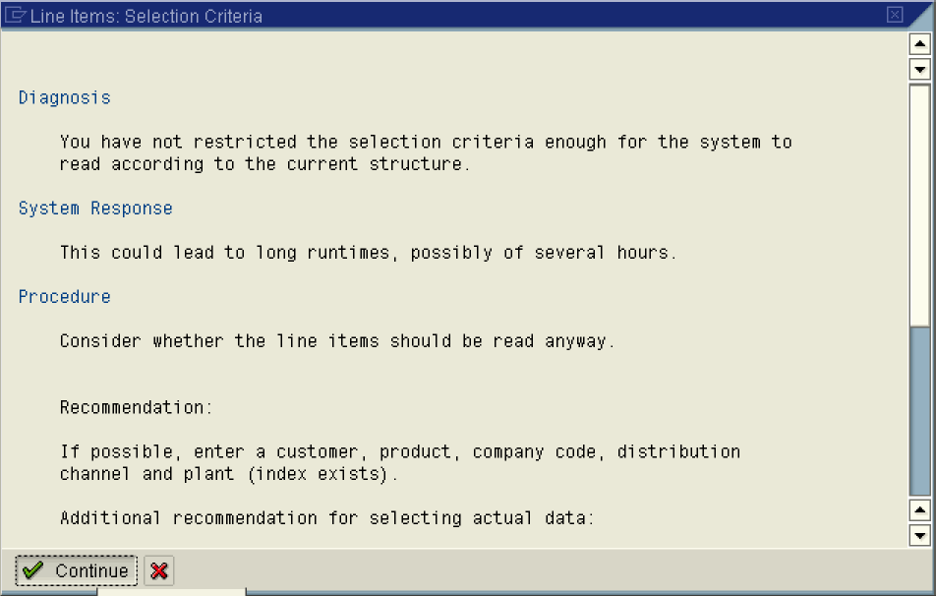

48. Click Continue Button .

Display Actual Line Items: List

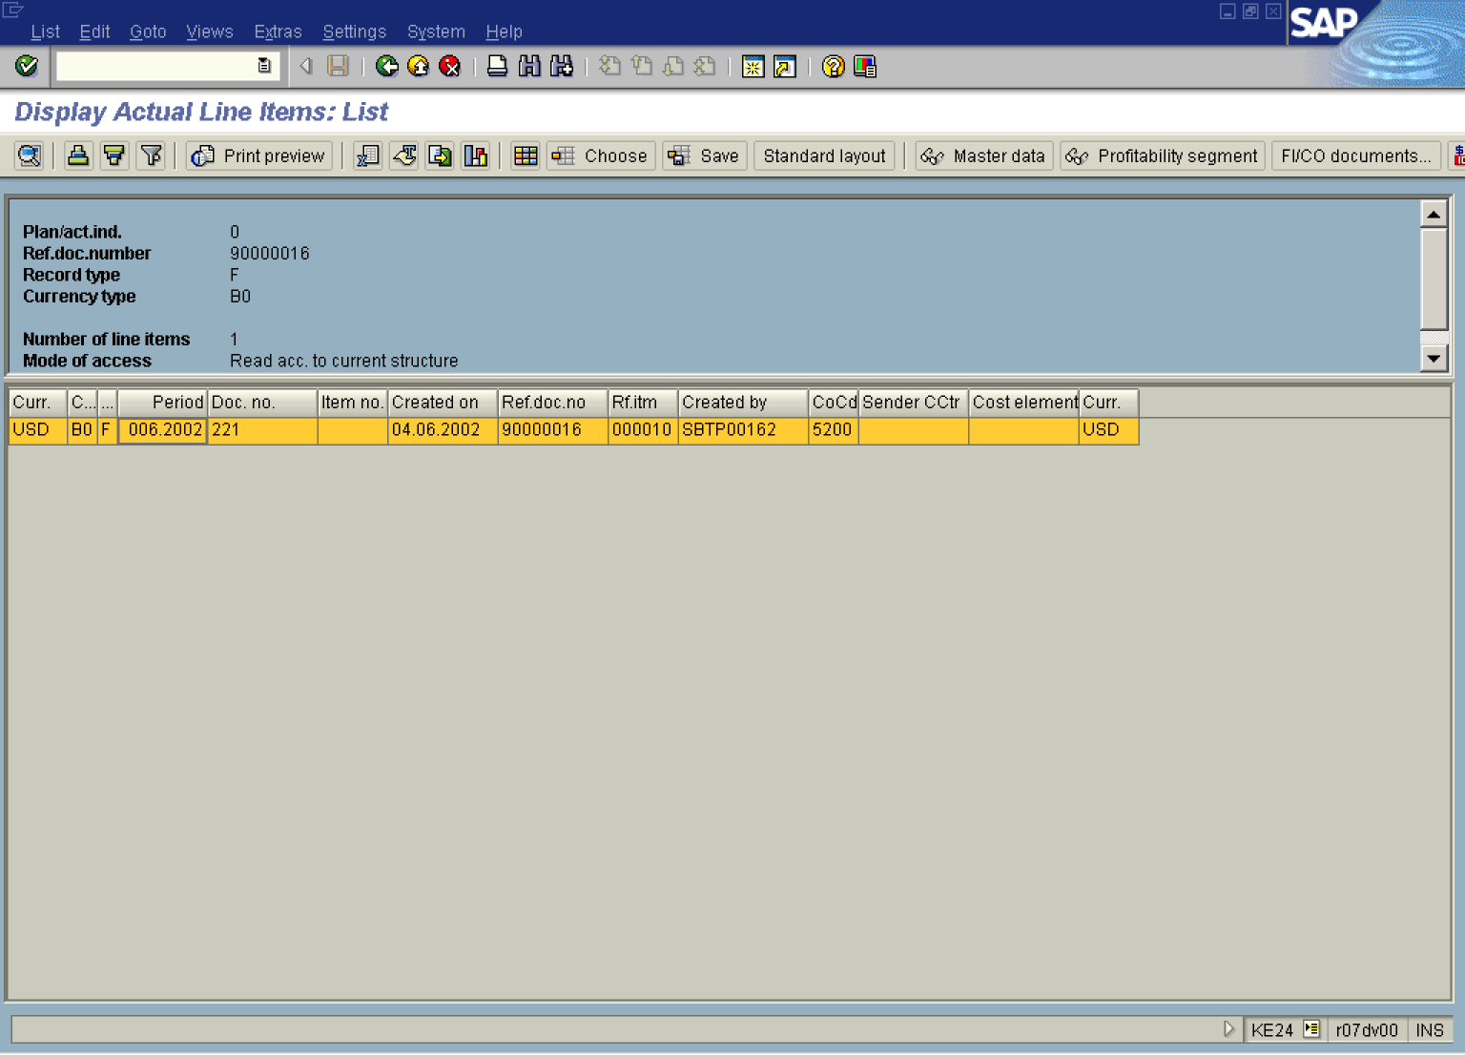

49. Select in list box to mark and double click on it.

Note: Now we can see that our realignment has taken place despite original billing document is still unchanged. Change of the material has only impact on CO-PA documents because of execution of our realignment run.

50. Click Integration Button .

Integration: Selection of Transactions

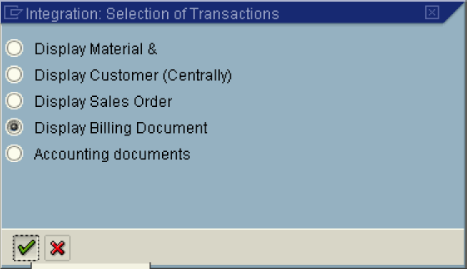

51. Click Display Billing Document .
52. Click the Continue button.

Invoice 90000016 (F2) Display: Overview of Billing Items

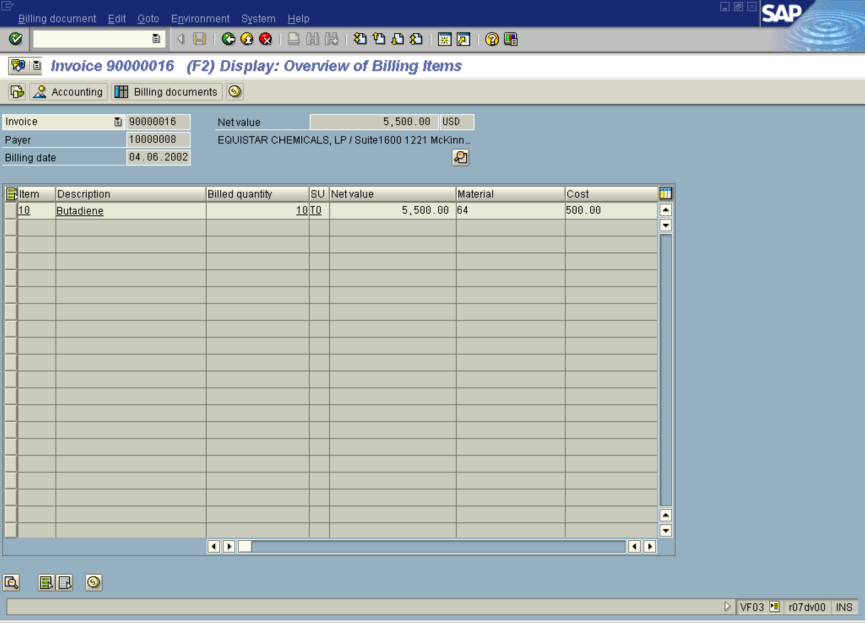

Invoice 90000016 (F2) Display: Item Data

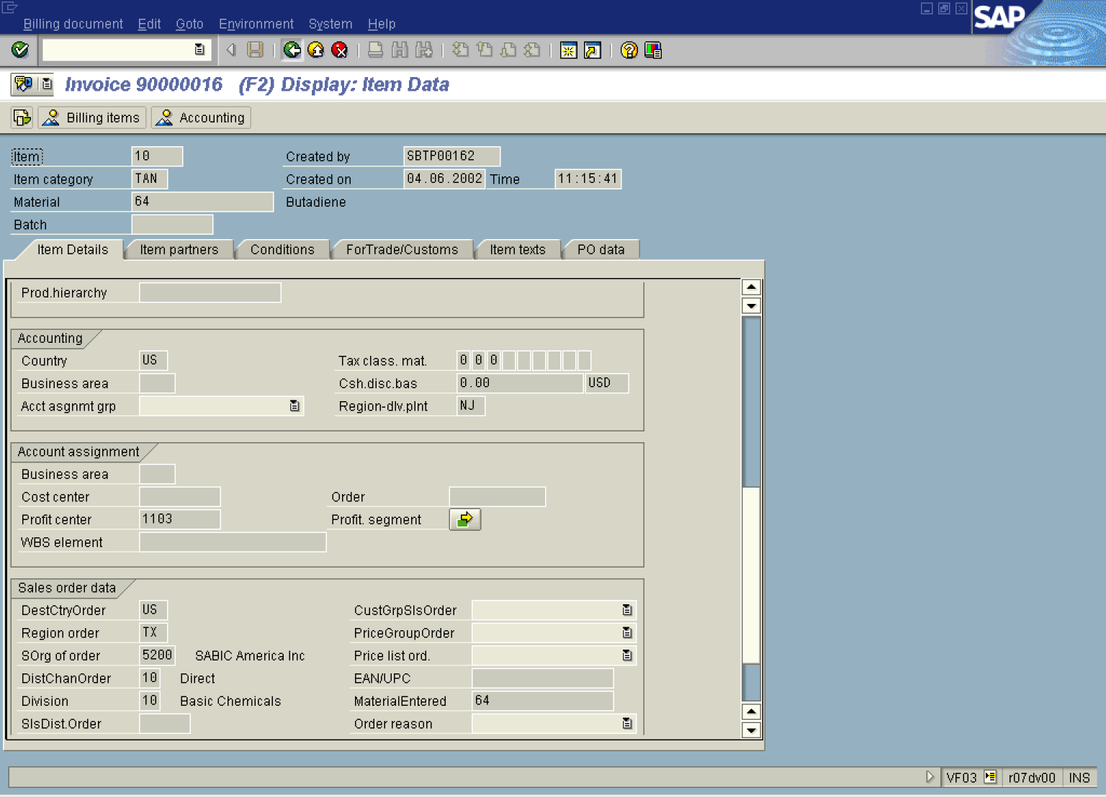

53. Click the Back button.

Invoice 90000016 (F2) Display: Overview of Billing Items

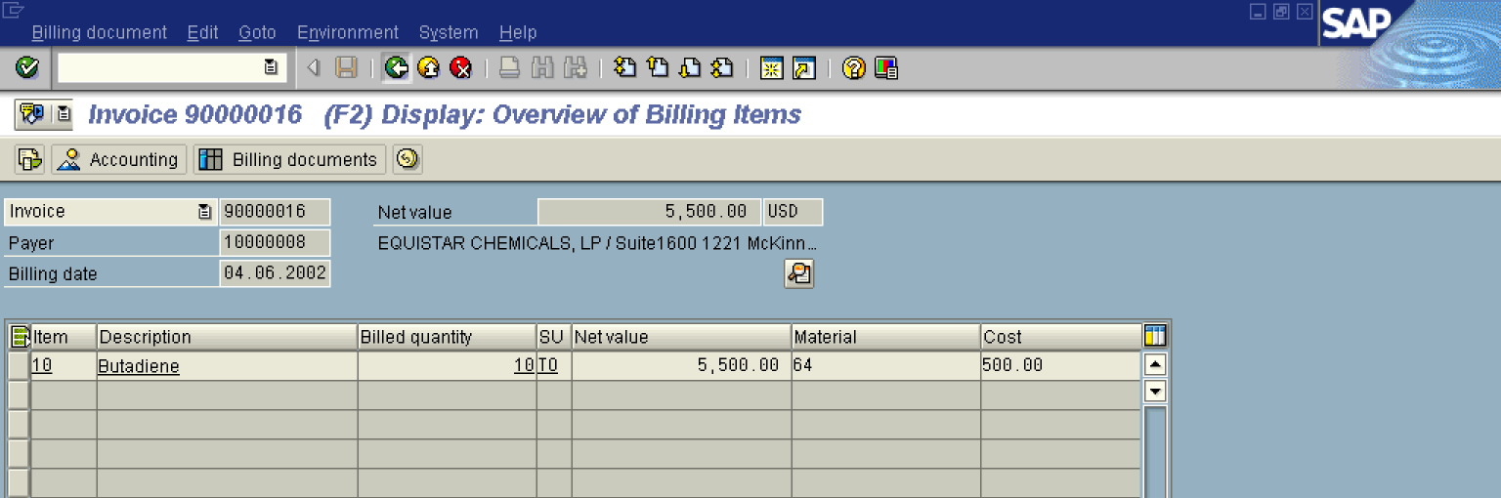

54. Click the Back button.

Display Line Items

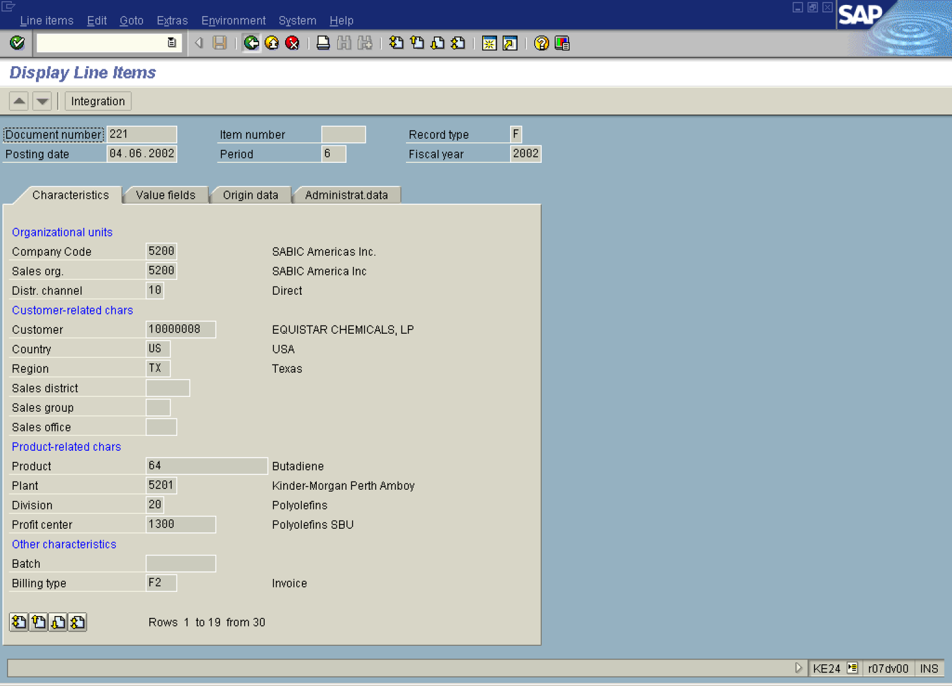
55. Click the Back button.
Display Actual Line Items: List

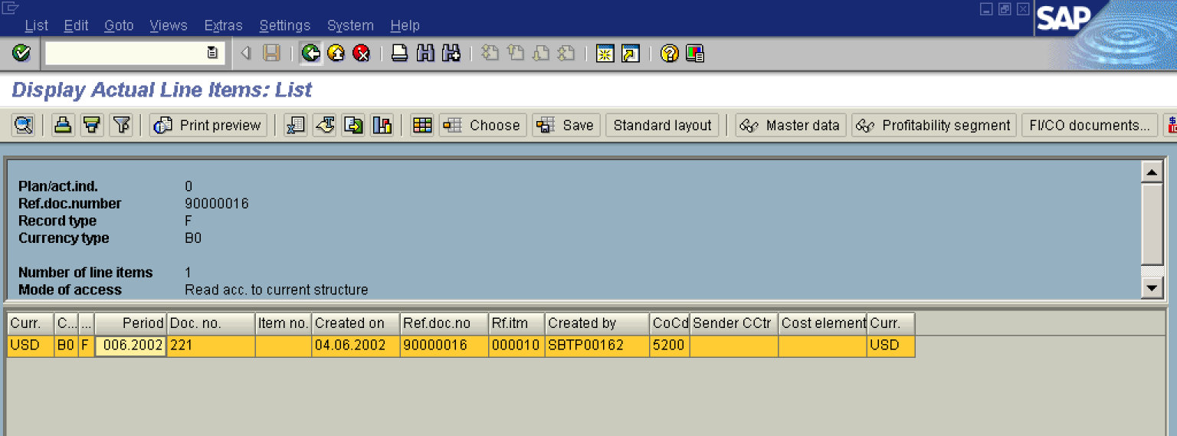

56. Click the Back button.

Display Actual Line Items: Initial Screen
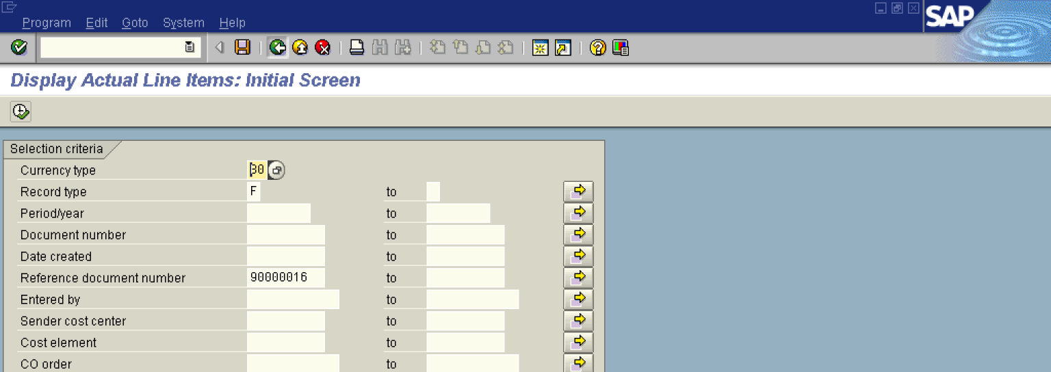

57. Click the Back button to go back to SAP Easy Access screen.

